Task 2: User Management and Access Control
Objective
To create secure user accounts for Sarah and Mike, provide isolated working directories, enforce access restrictions, and apply a password expiration policy in line with organizational security standards.
Step 1: Create User Accounts
Create user Sarah & Mike as well as Verify users
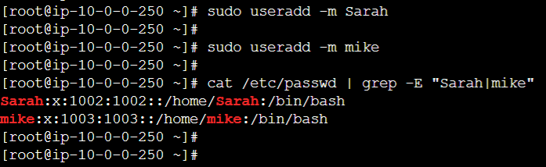

Step 2: Set Secure Passwords
Set password for Sarah & Mike:
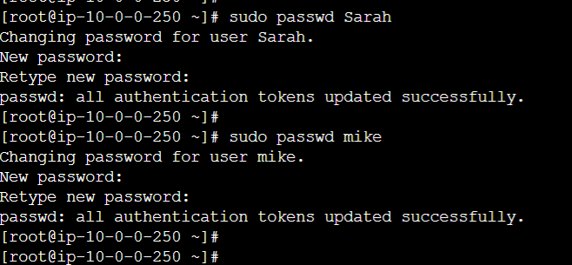

Step 3: Create Dedicated Workspace Directories
Sarah & Mike’s workspace & Assign Ownership to Respective Users:
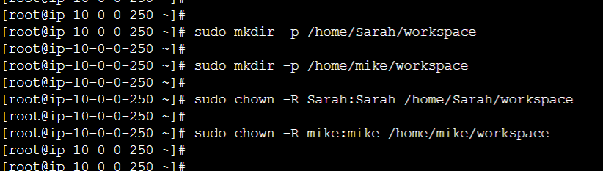

Step 4: Set Proper Permissions (Access Control):
Ensure only the owner can read/write/execute it as well as Verify permissions:
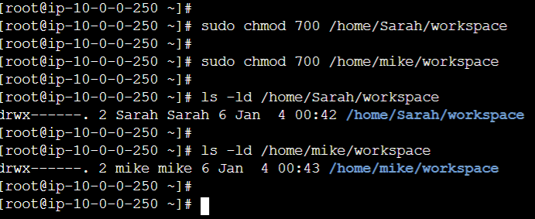

Step 5: Test Isolation
Switch to Sarah & mike respectively & check isolation status of each user:
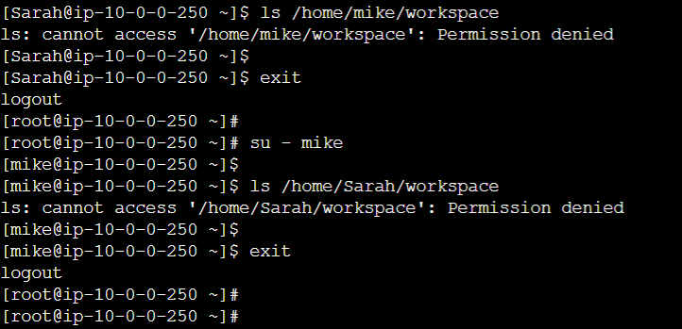

Step 6: Implement Password Expiration Policy (30 Days)
Set password expiry for Sarah & mike as well as verify policy:
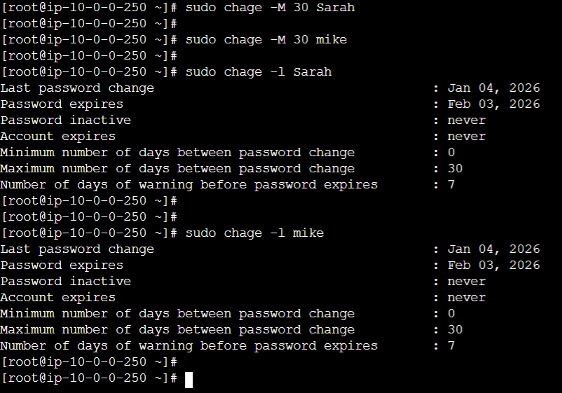

Enforce Password Complexity
This enforces:
Minimum 8 characters
Uppercase, lowercase, number, special character
